Recommendation Letter from the intern organization

Recommenation letter from the college

Declaration

Table of content

List of content

List of figure

Description of projects

3.3.1 JWT Authentication using ExpressJs

**JWT Auth Blog API** is a practice backend project built using **Node.js and Express** to understand and implement **user authentication using JWT** and basic **CRUD operations**. The project includes APIs for managing users and blog posts.

**Key Features:**

• **JWT Authentication**: Simple login and registration system using JSON Web Tokens for secure access.  
• **User API**: Users can register with their email, username, password, and age.  
• **Blog API**: Users can create, read, update, and delete blog posts with a title, description, and author.  
• **Protected Routes**: Only authenticated users can access certain blog-related endpoints.  
• **Practice Project**: This was built for learning purposes to get hands-on experience with authentication and REST APIs in Express.

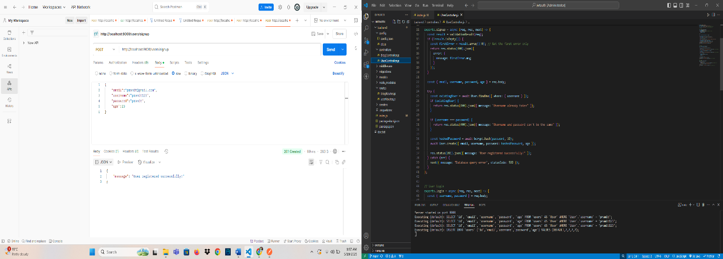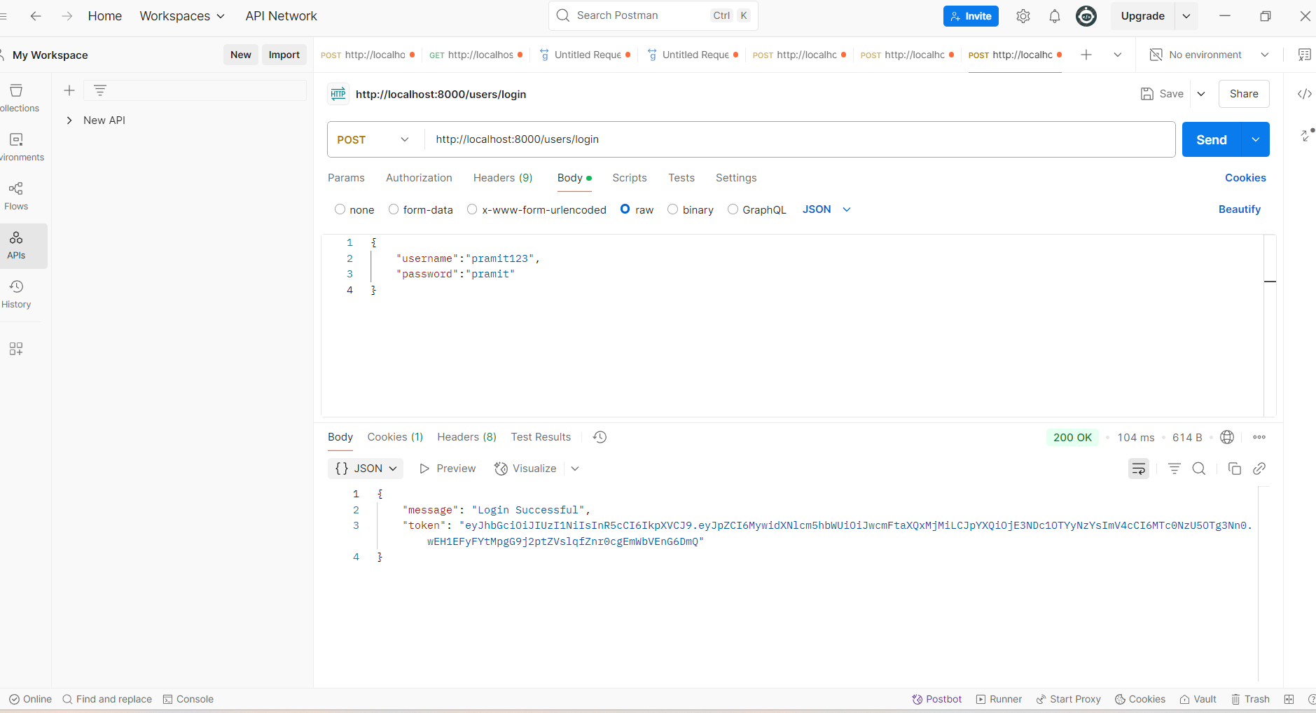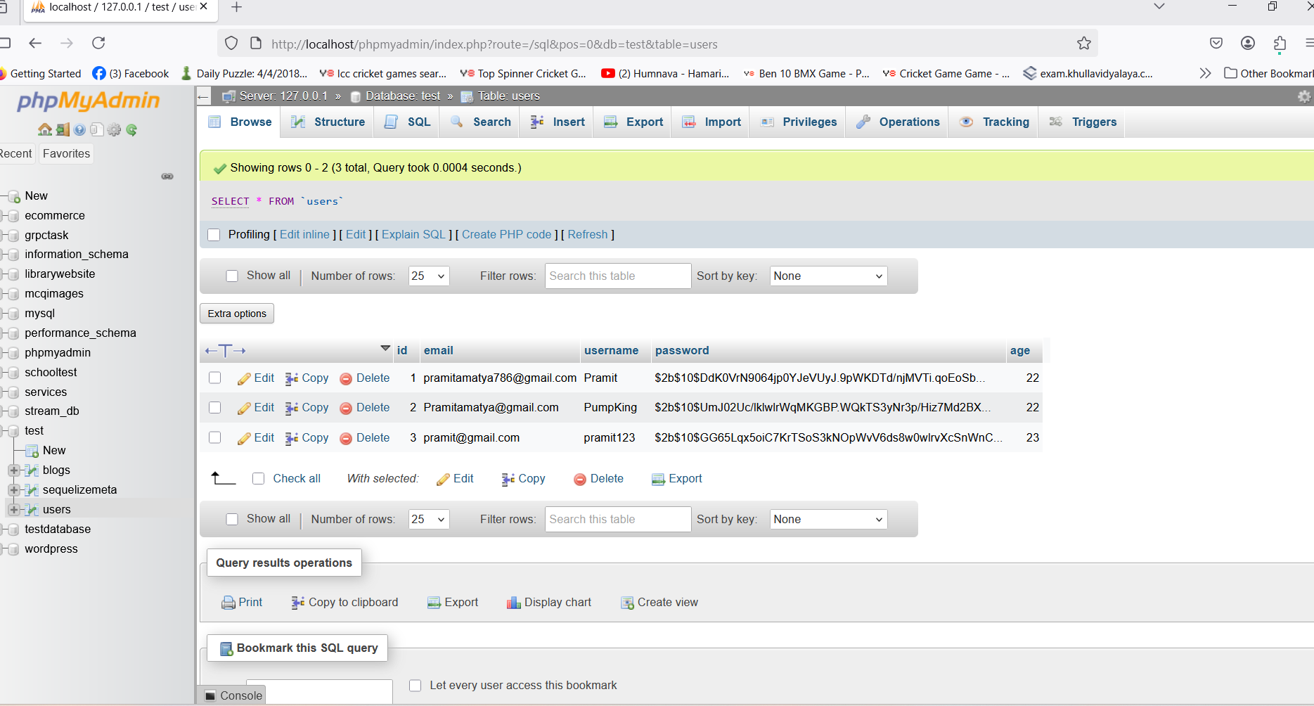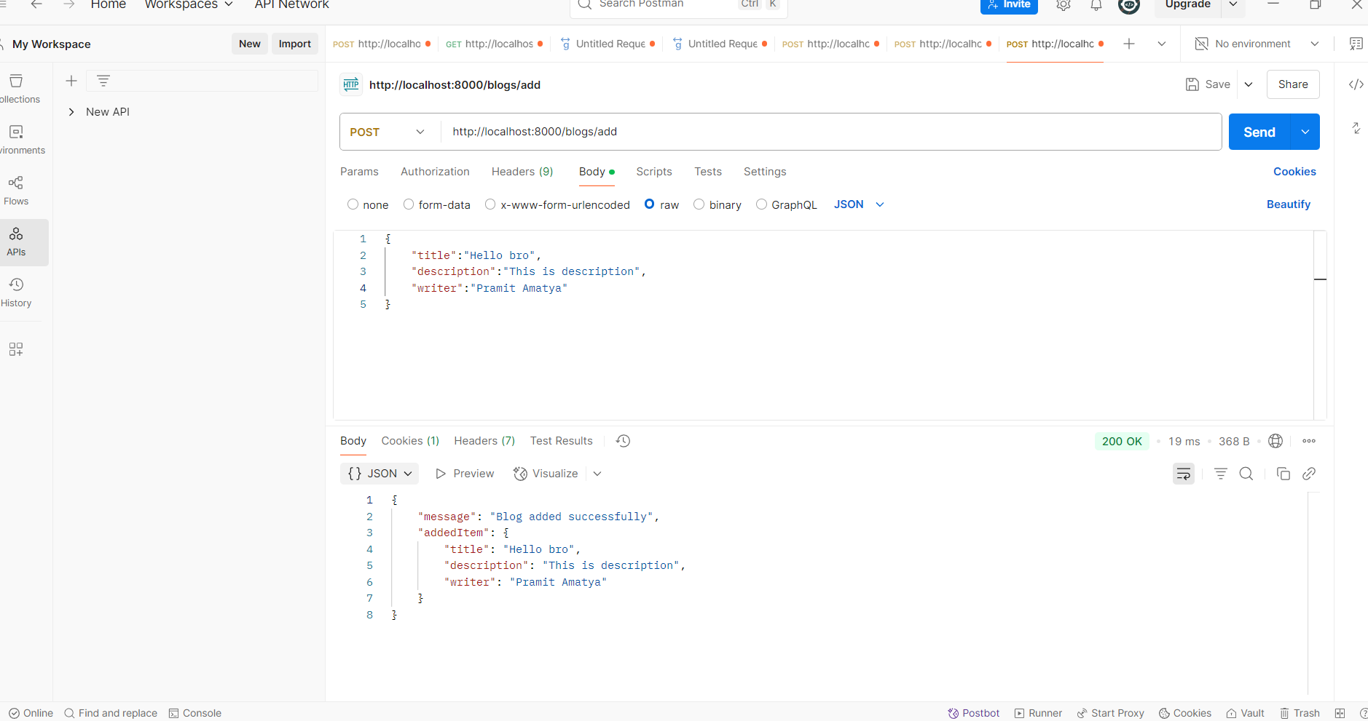

3.3.2 GRPC mini-project

**gRPC Auth Blog Service** is a practice backend project built using **Node.js and gRPC** to learn how to implement **authentication with JWT** and manage **user and blog data** using **protocol buffers and gRPC services** instead of REST APIs.

**Key Features:**

• **JWT Authentication**: Login and registration implemented with JSON Web Tokens for secure communication.  
• **User Service**: Handles registration and login with fields like email, username, password, and age.  
• **Blog Service**: Users can create, read, update, and delete blog posts with title, description, and author.  
• **Protected RPC Methods**: Certain blog operations are accessible only to authenticated users.  
• **Practice Project**: Built for learning purposes to understand how gRPC works in Node.js and how to replace traditional REST with gRPC calls.

